cut –c –5 data – This command will print all columns from 1 to the 5 th.

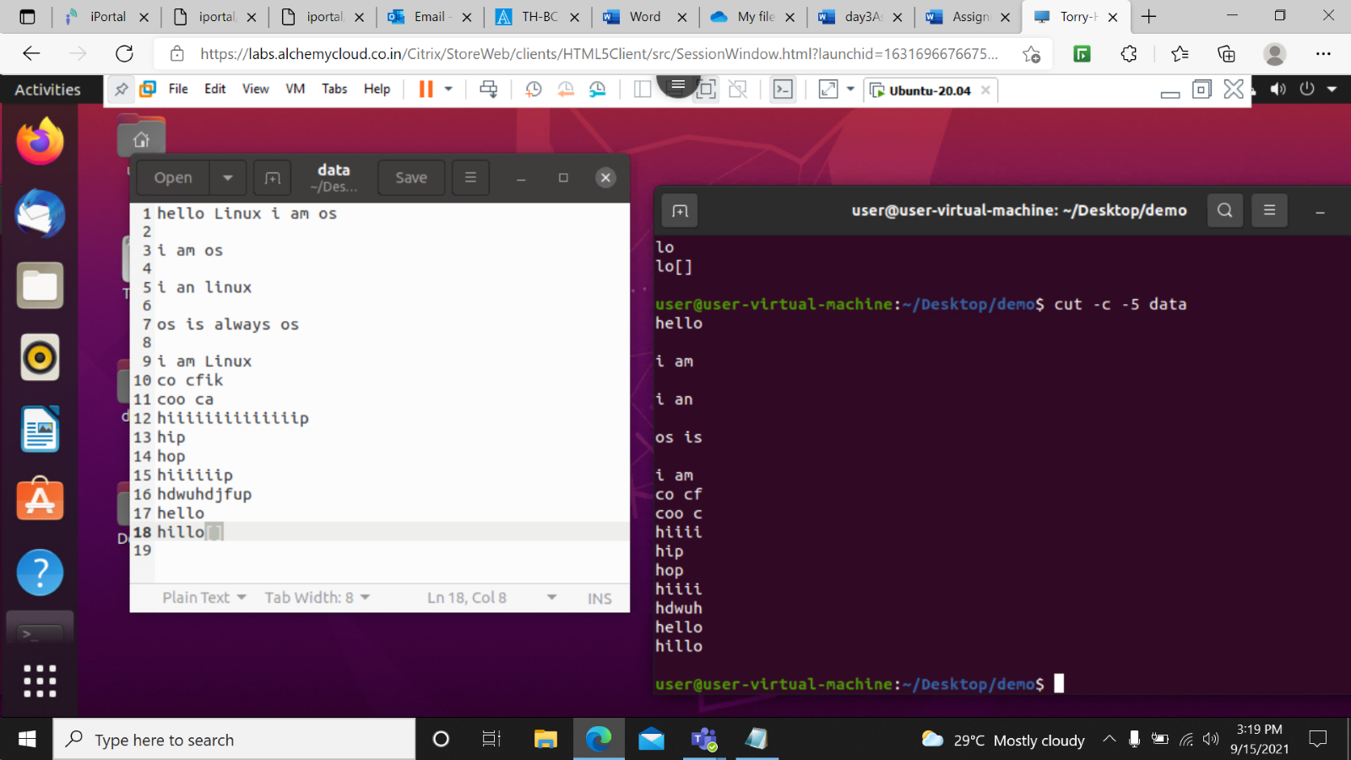

cut –c 1,5-7 data- This command will print column 1 as wll as columns from 5 to 7 from the file.

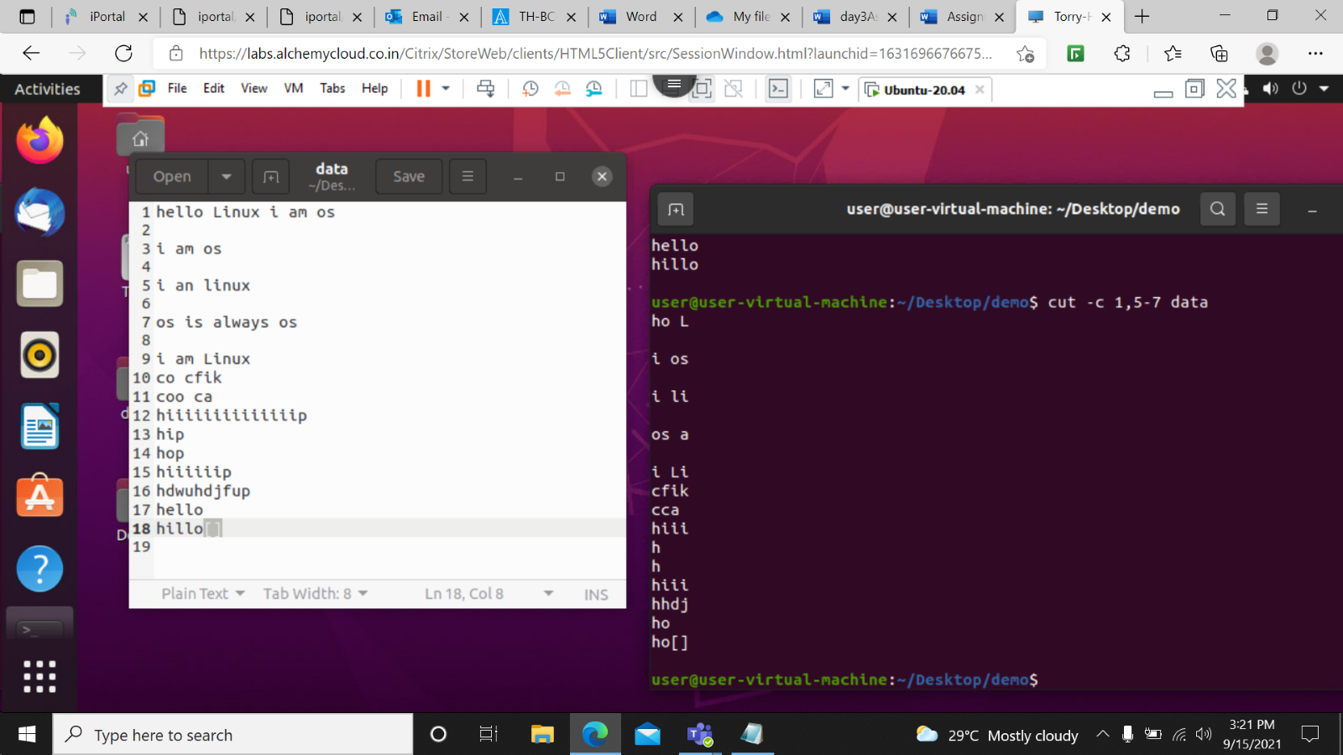

cut –b 5-9 data- This command will print bytes from 5 th to 9 th column

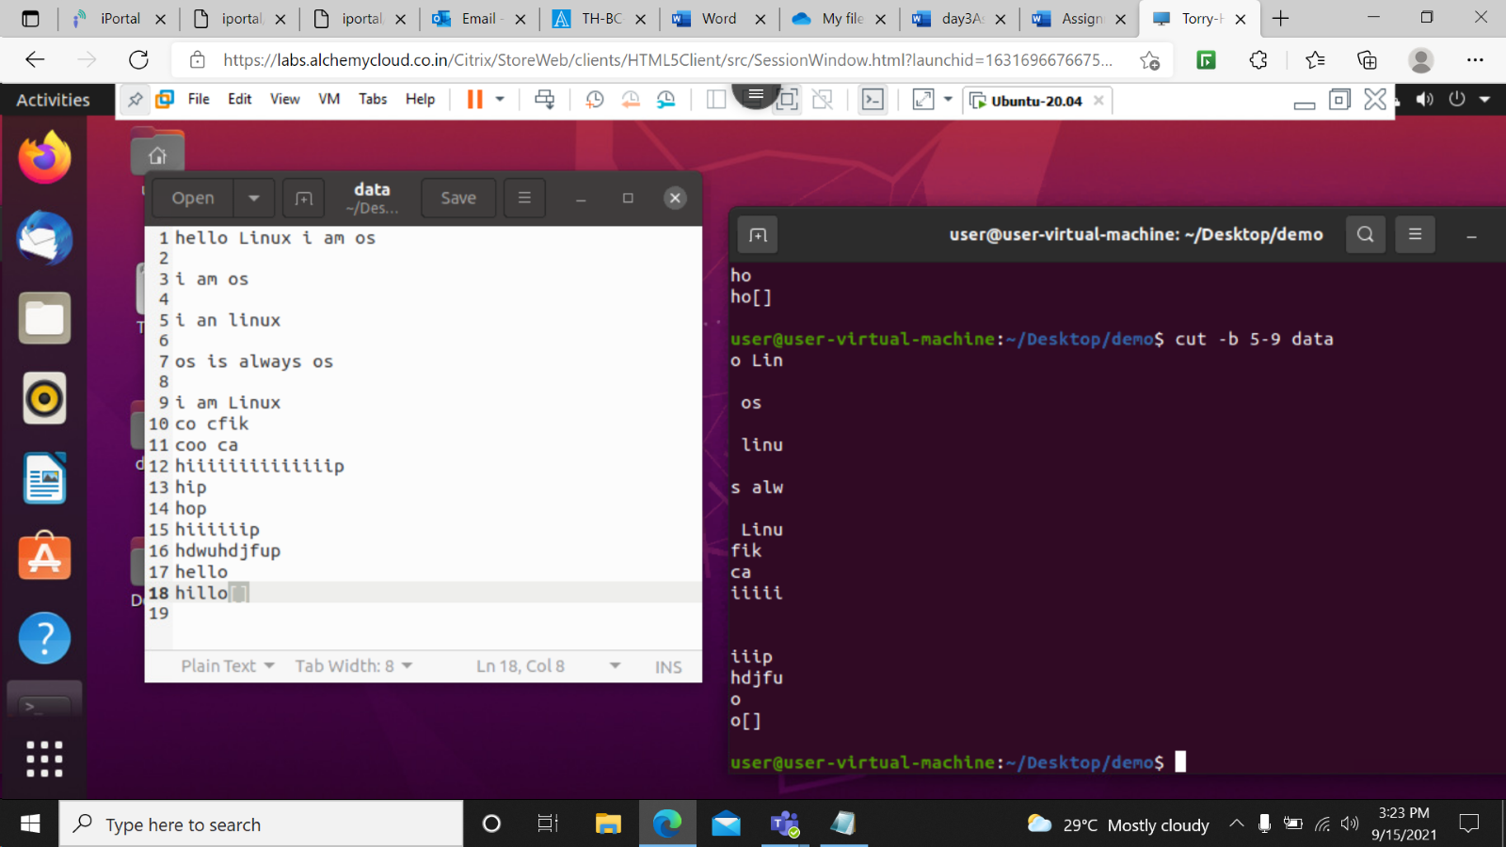

cut –d ‘ ‘ -f 1 data-This command prints all data till the first space in every line .

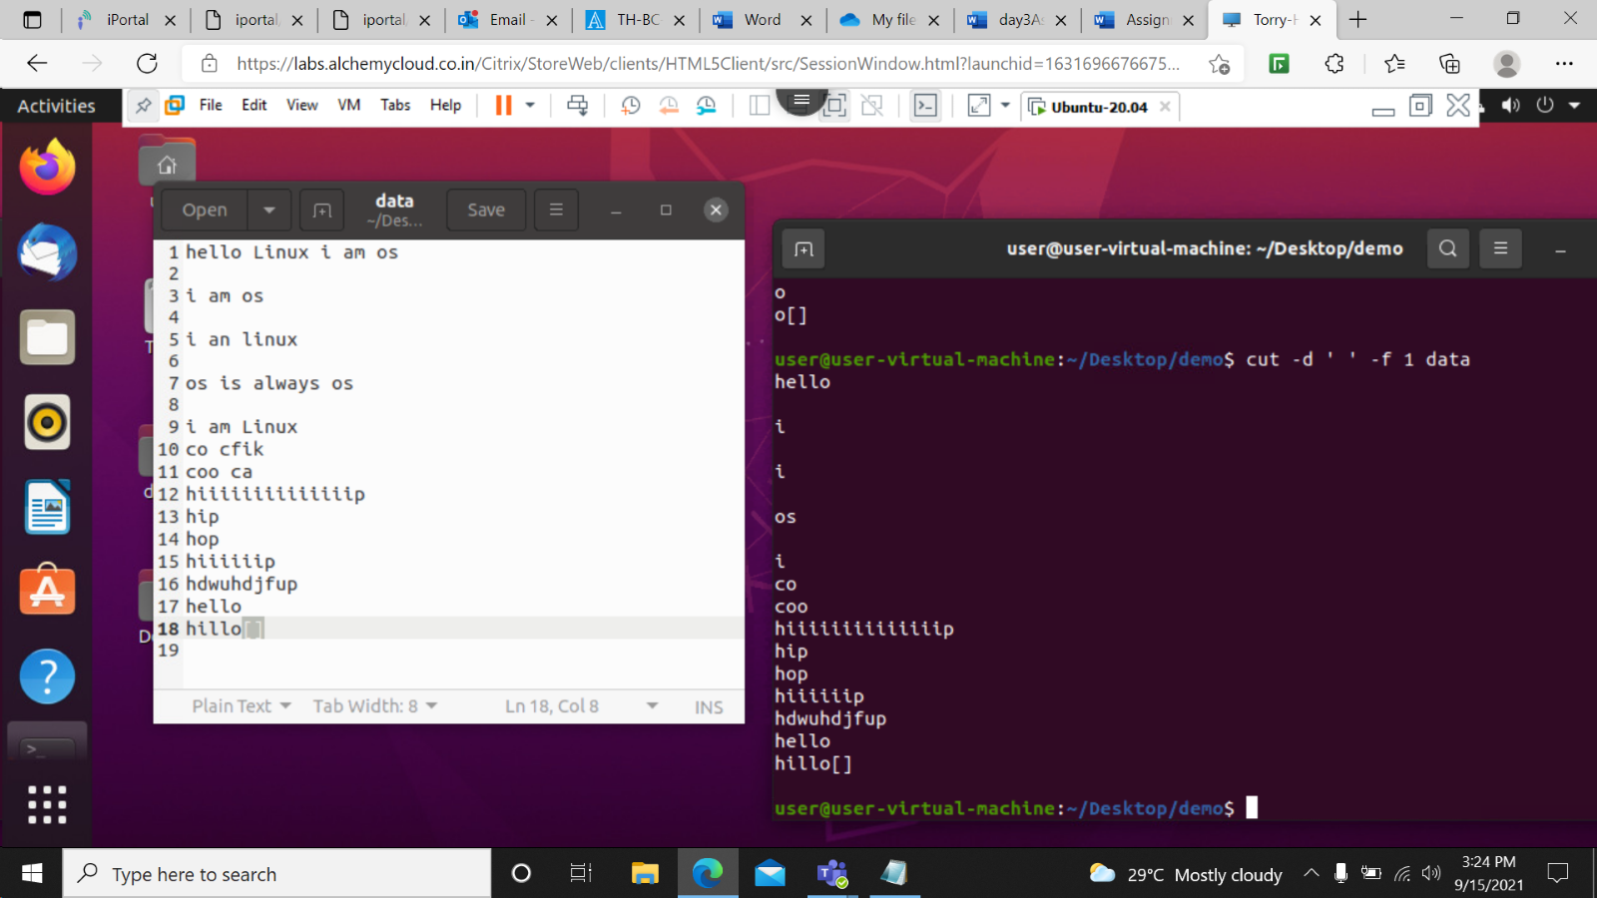

cut –d ‘s‘ -f 1 data- This command prints all data till the s char in every line .

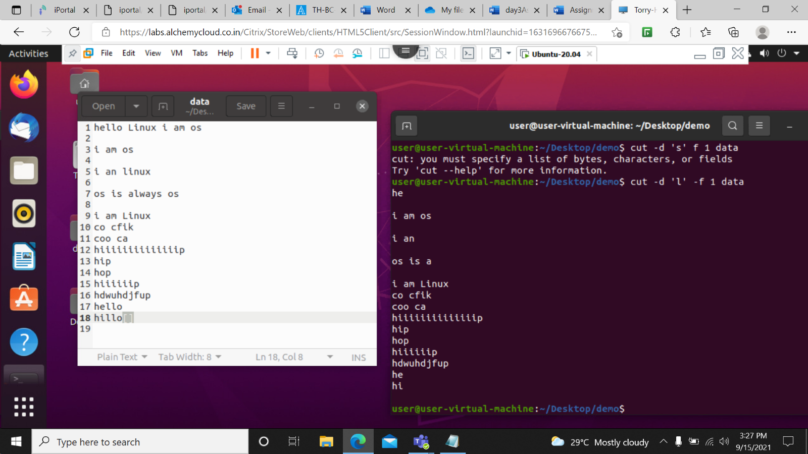

cut –d ‘c’ -f –2 data- This command prints the data till second c.

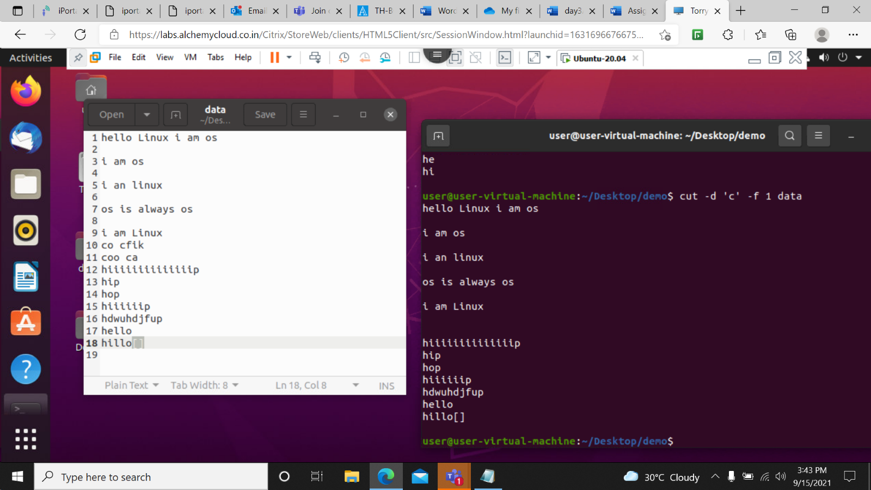

cut –c 2-4,6- data // cut – complement –c 1,5 data

This two commands do exact same task they print all the columns except 1 &5.

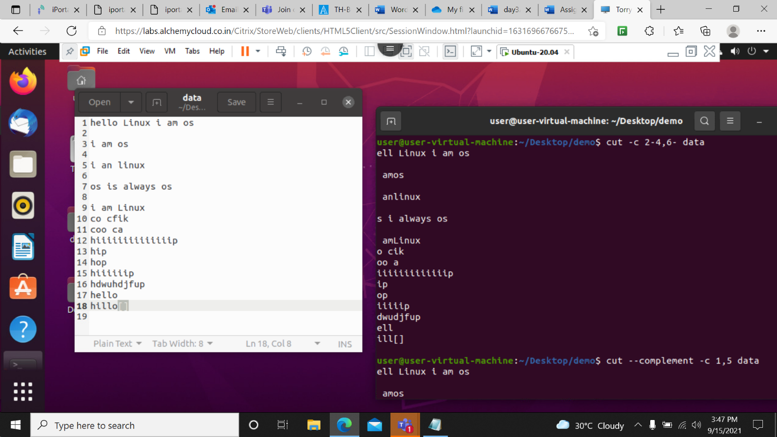

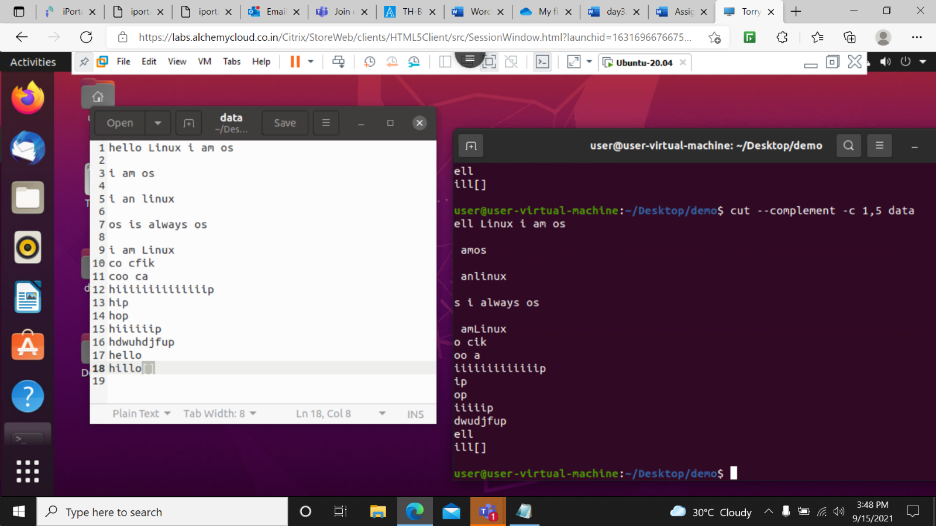

cut –complement –d ‘ ‘ -f 3 data- This command prints all column except 3rd one.

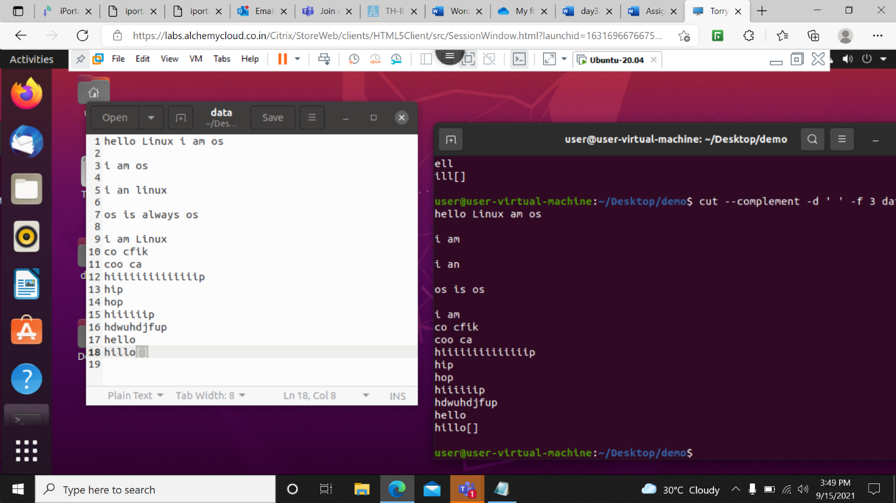

cut –complement –b 1 data- this will print entire string except 1st byte.

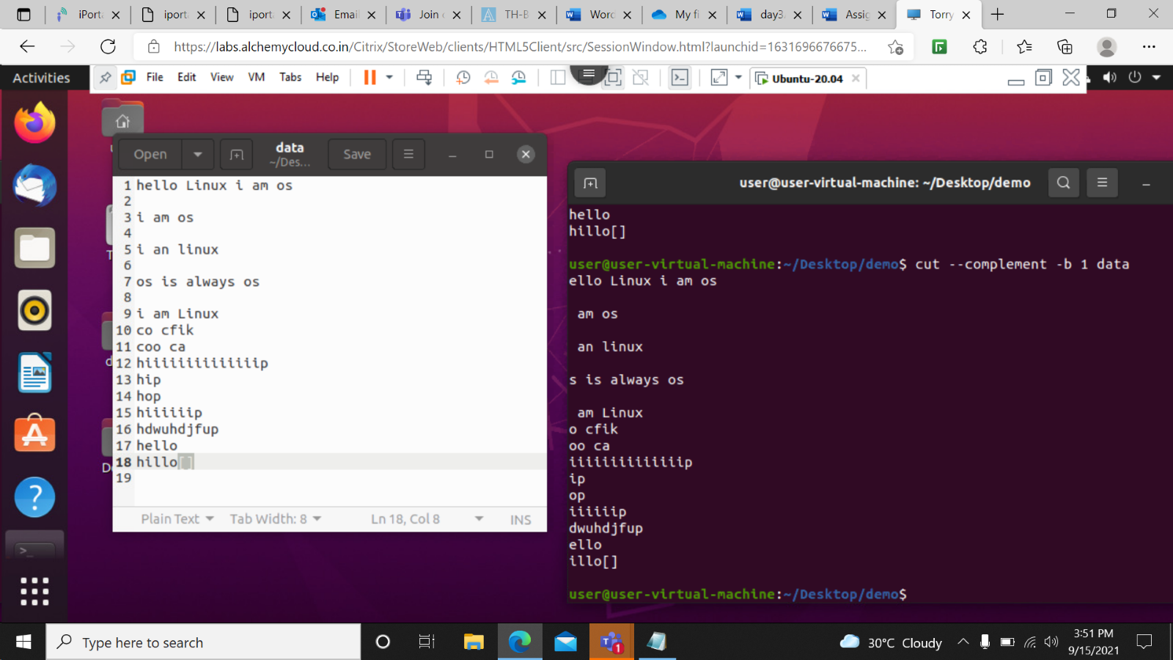

cut –d ‘ ‘ -f 1 data –output-delimiter=’\*’ - This will print output with the \*mark.

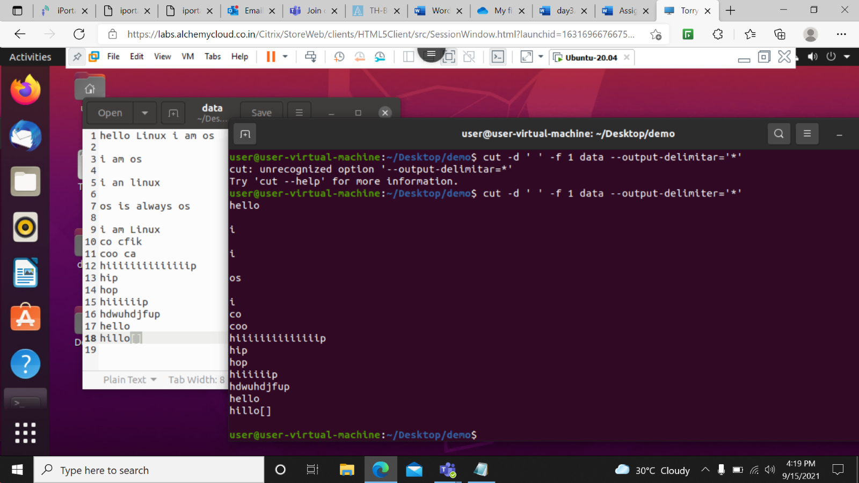

cut –complement –d ‘ ‘ -f 1 data –output-delimiter=’\*’- This command will print \* after every space in the string.

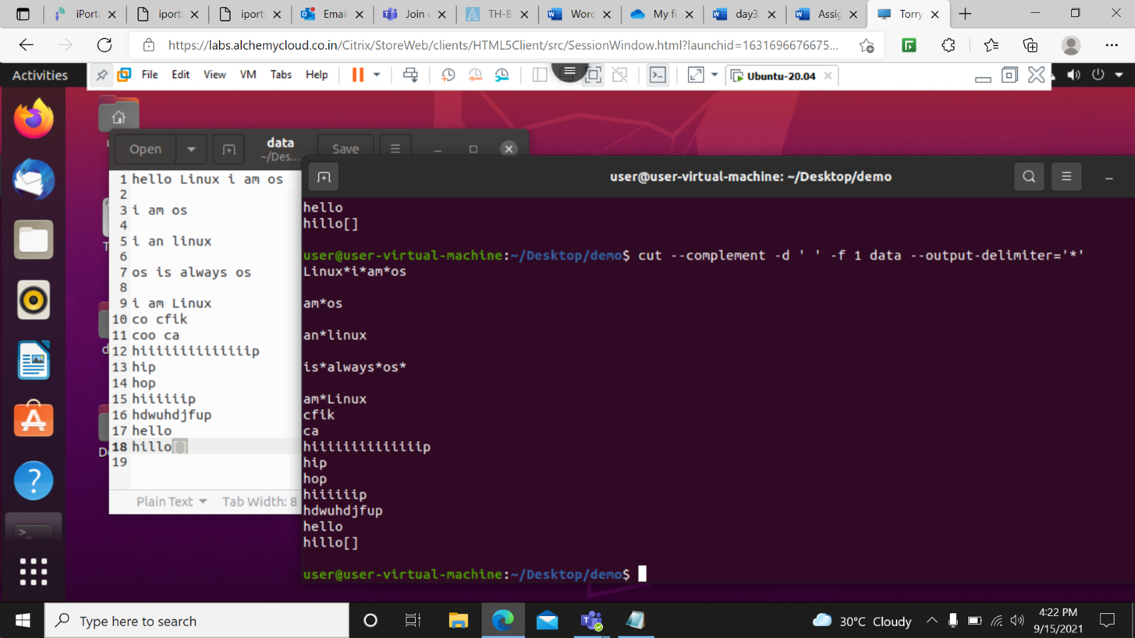

cut –d ‘ ‘-f 1 data| sort – This command will sort the string according to the dictionary which is output of first command .

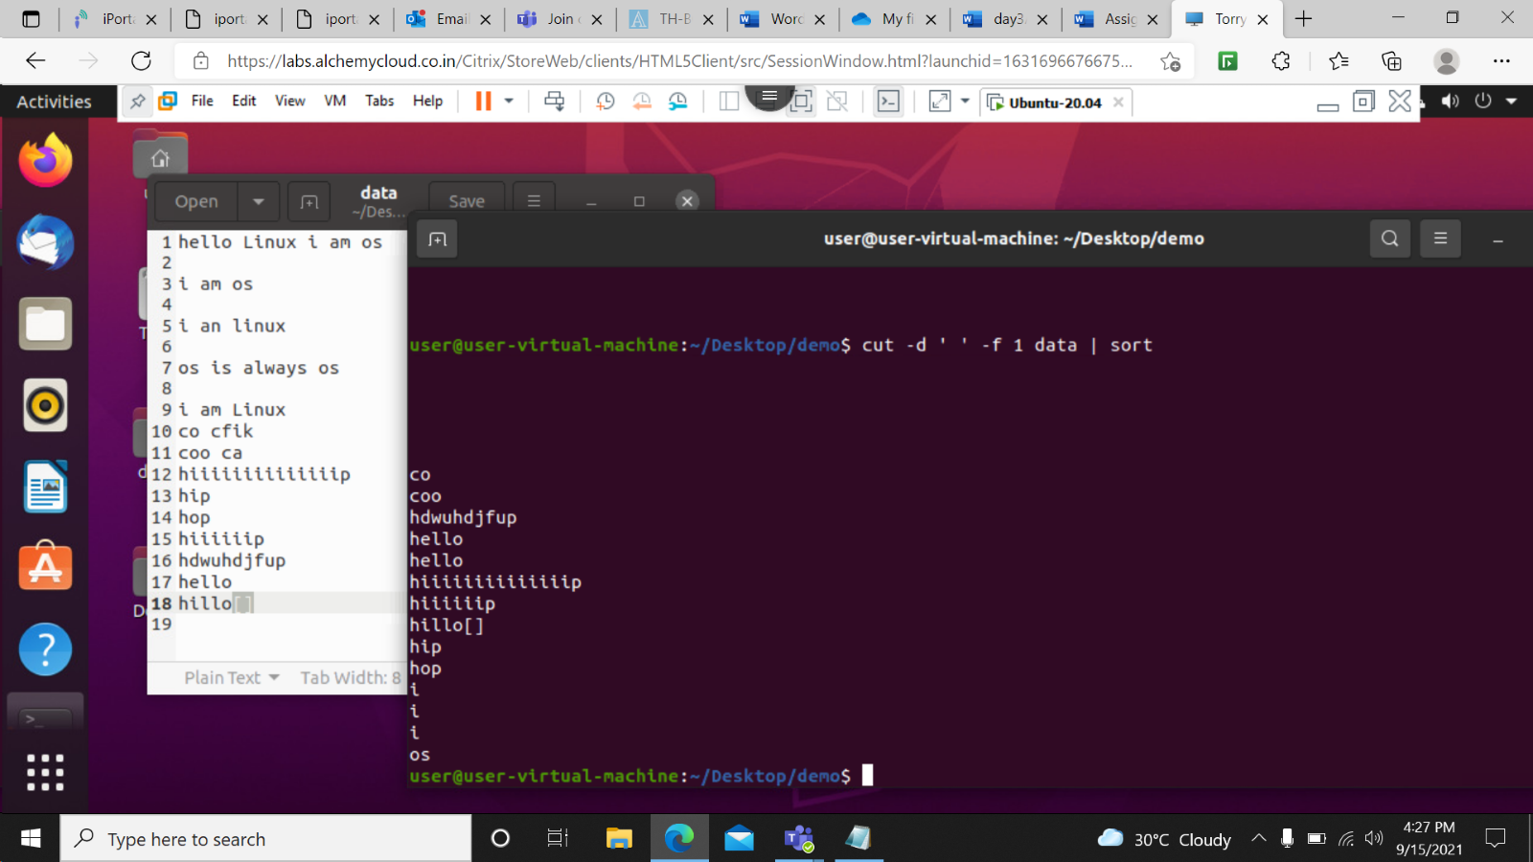

cut –d ‘ ‘-f 1 data| sort -r – This command will sort the string according to the reverse dictionary which is output of first command.

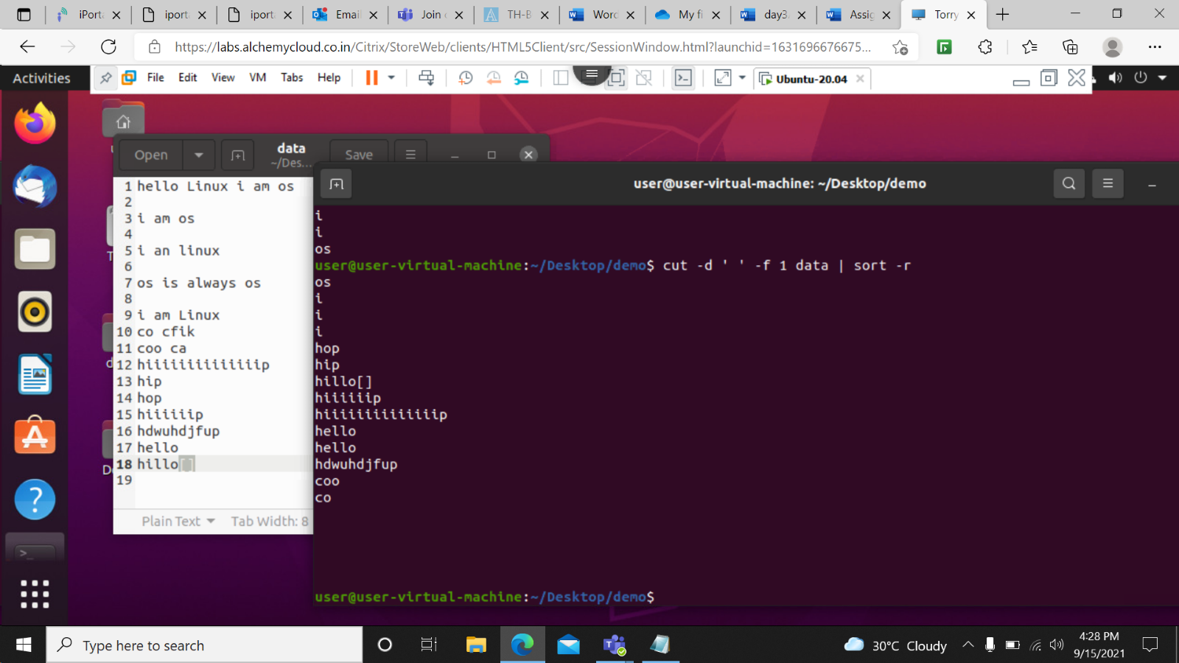

cat data | tr ‘[a-z]’ ‘[A-Z]’-This command is used to change the lower case letter to the upper case.

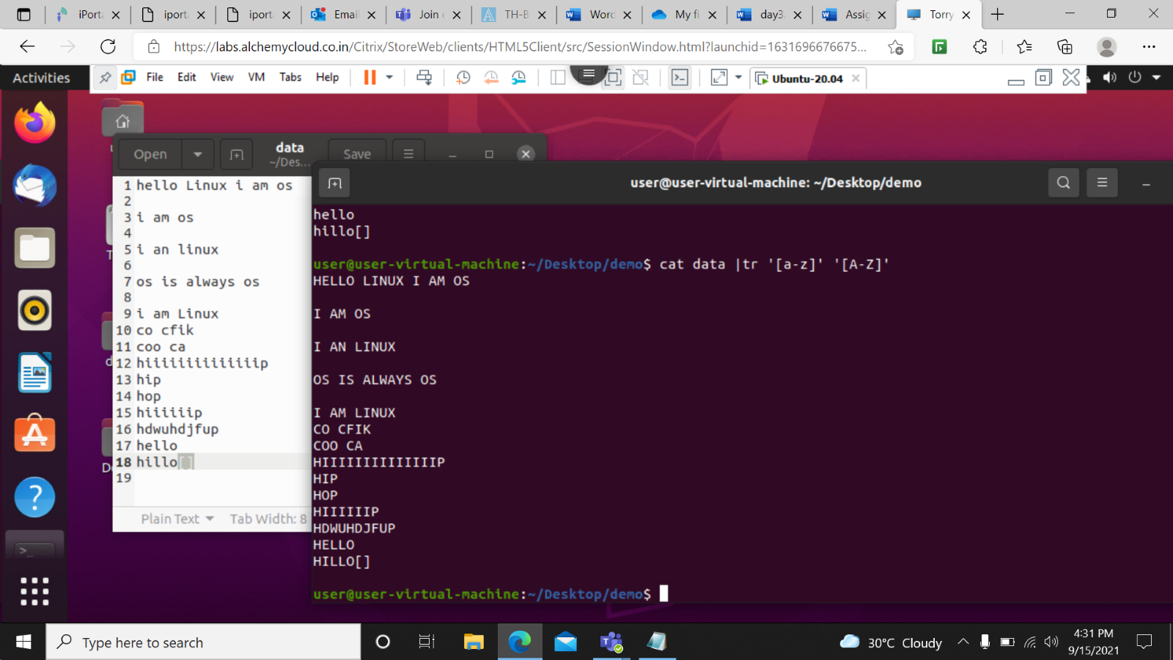

cat data | tr ‘[:lower:]’ ‘[:upper:]’-This command is used to change the lower case letter to the upper case.

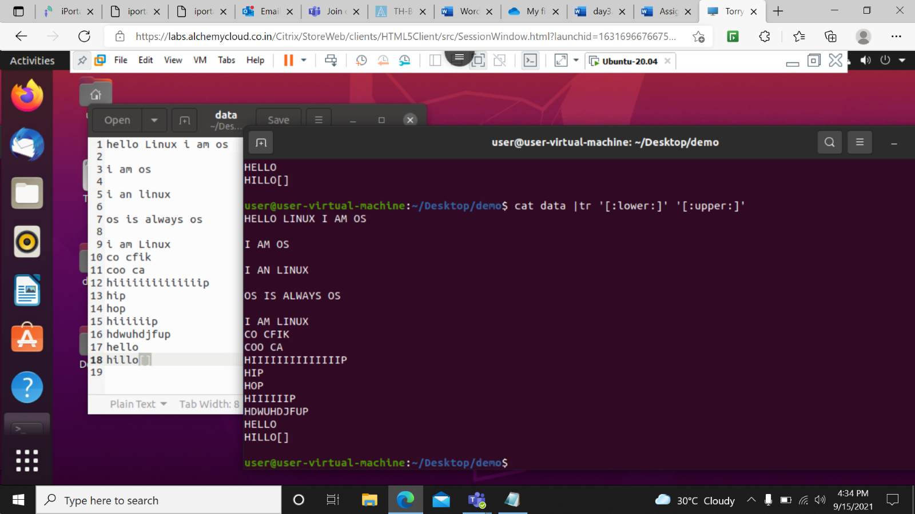

echo “hello I am linux” | tr ‘[:lower:]’ ‘[:upper:]’- this command prints the message as well as it changes lower case letters to upper case.

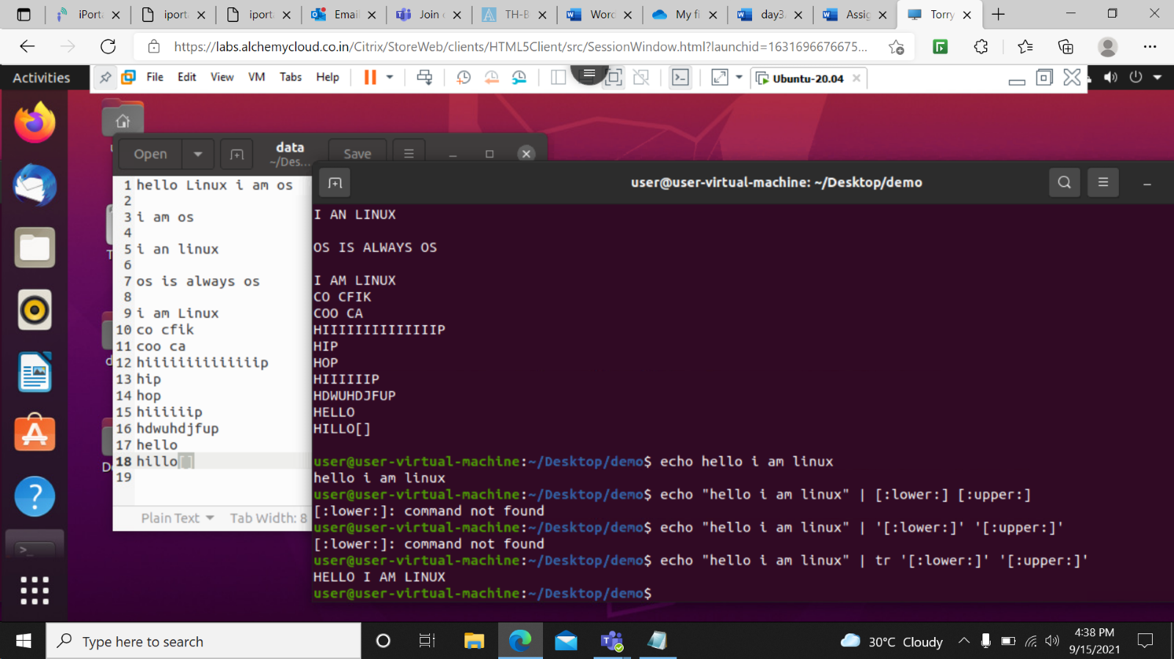

cat data | tr –s [:space:] ‘ ‘- This prints data as well as it removes too many spaces present in the file.

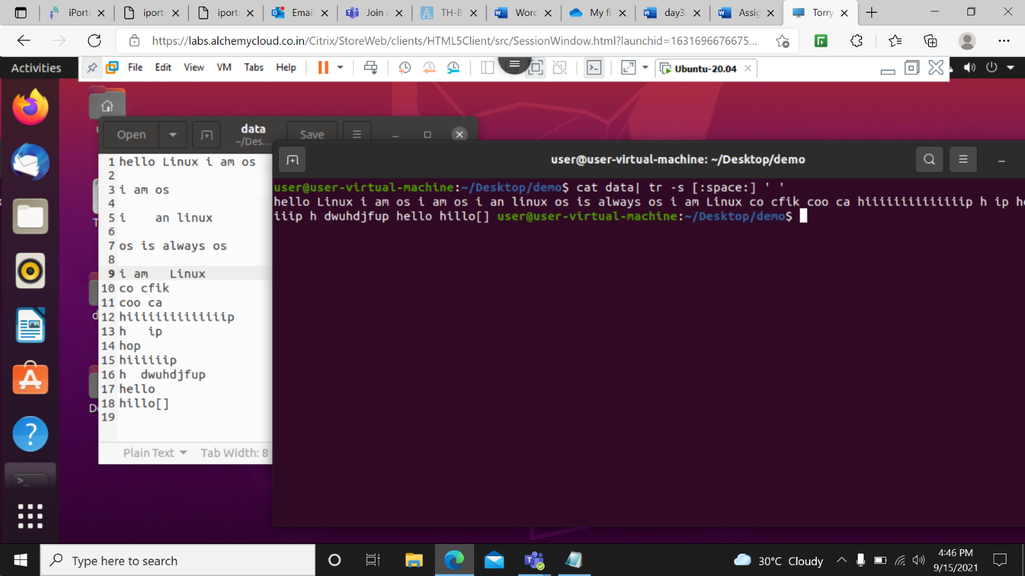

cat data | tr –d ‘i’ - This command deletes all i in the file prints the file.

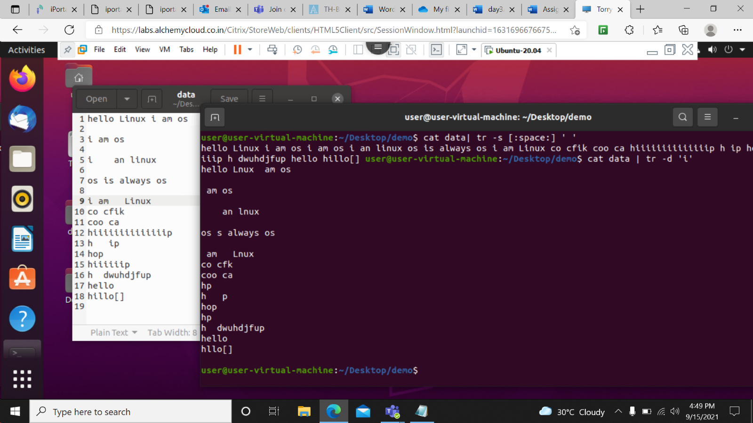

cat data | tr –d ‘[digit:]’- This command is used to delete the all digits present in the file.

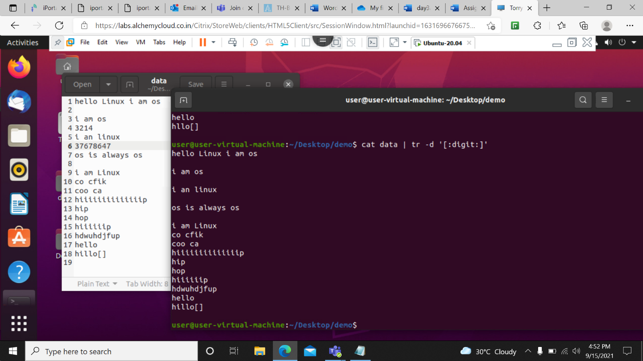

cat data | tr –d ‘[:upper:]’- This command is used to delete the all upper case letters present in the file.

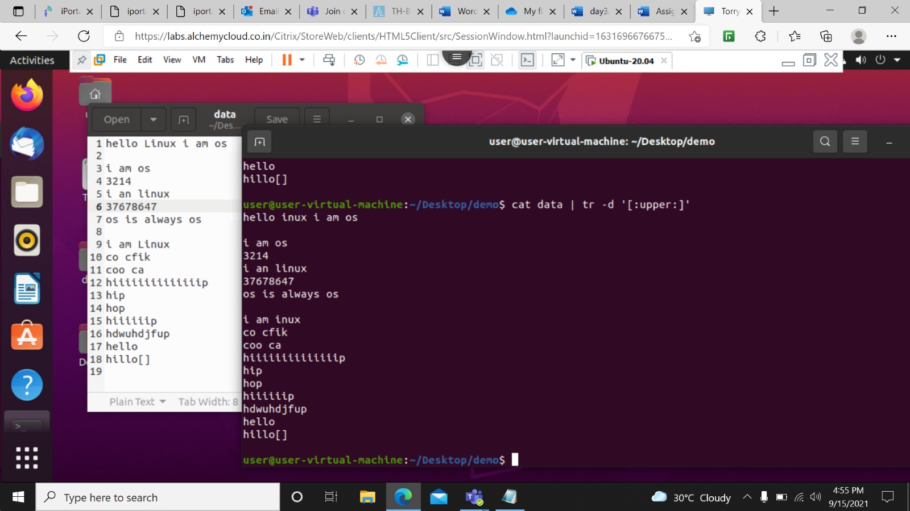

cat data | tr –d ‘[a-i]’- This command is used to delete all the char. From a to i in the file.

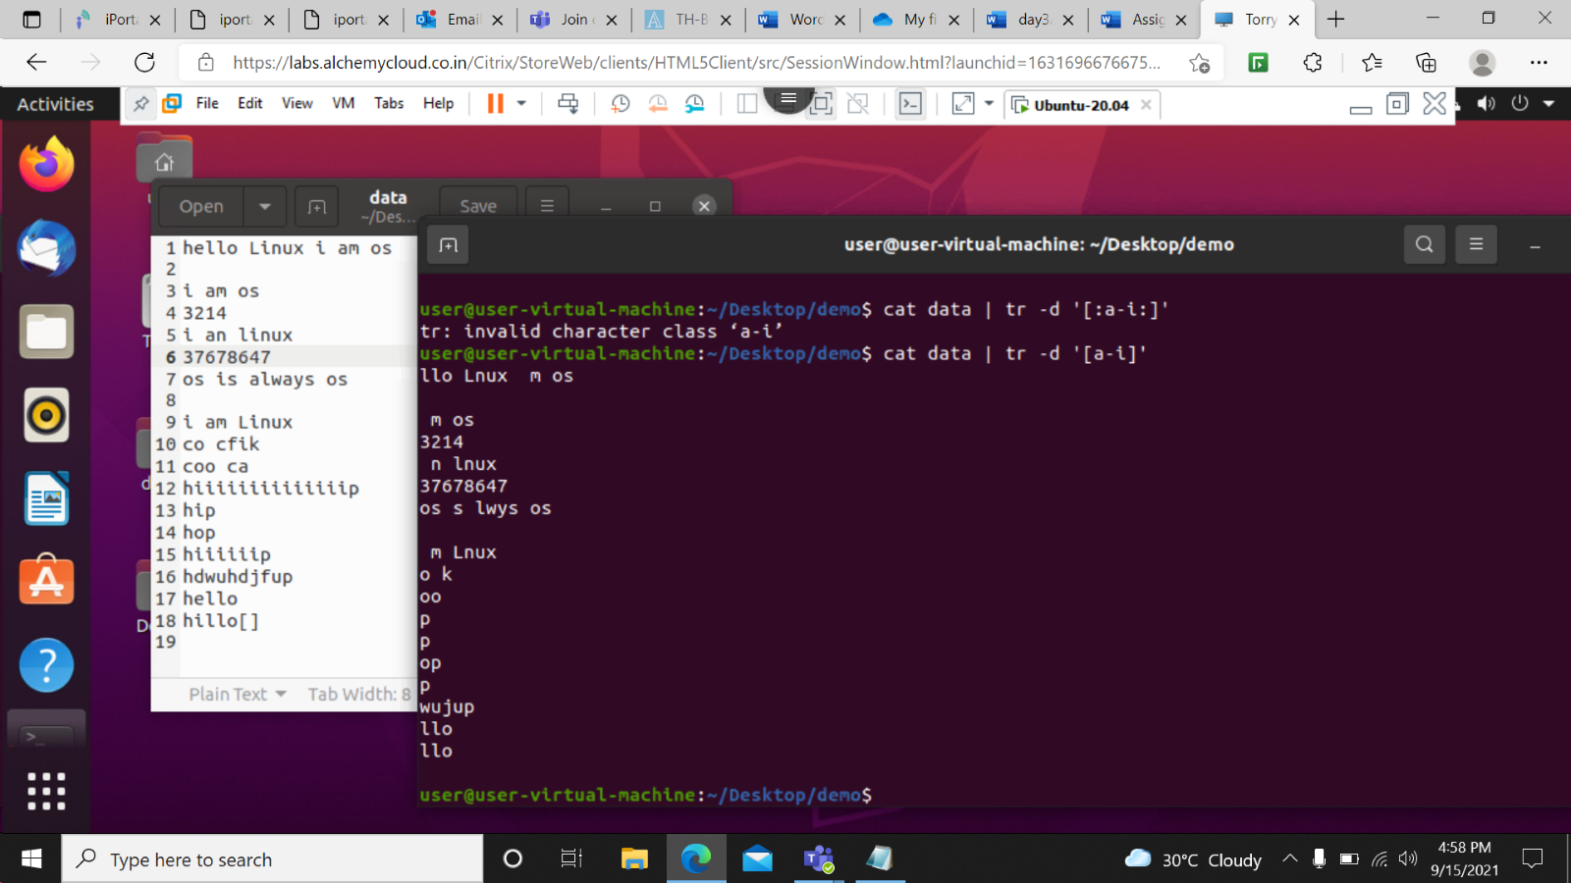

cat data | tr –d –c ‘[a-i]’- This command is used to delete all the char. except From a to i in the file.

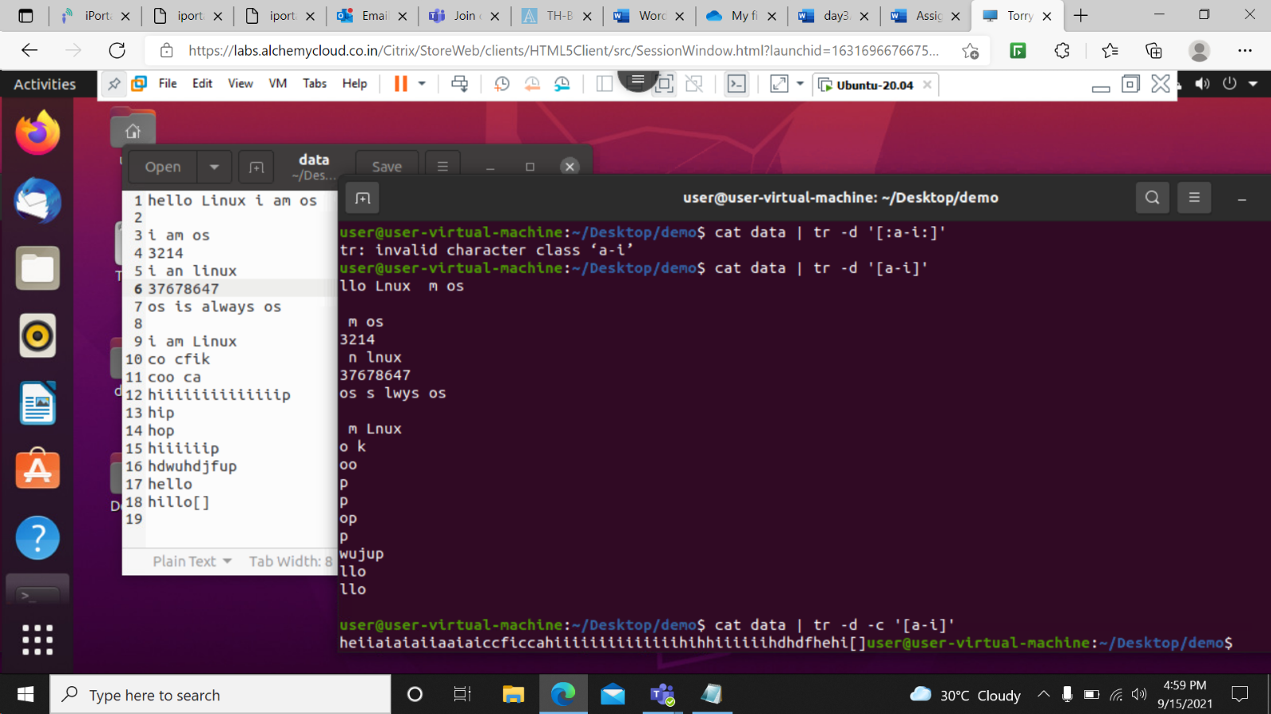

cat data | tr –d ‘[:upper:][:digit:]’- This command is used to print the string as well as it deletes the upper case letters and digits.

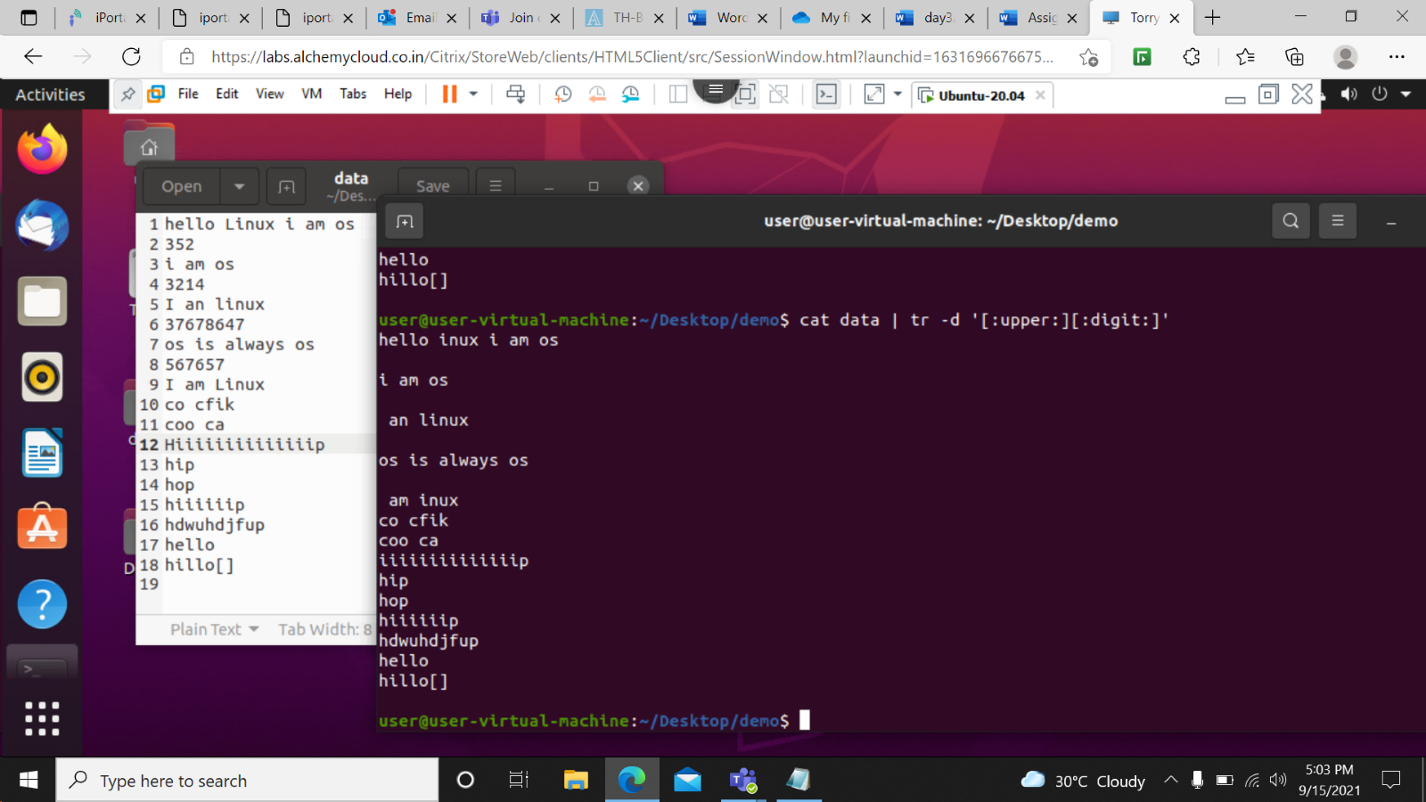

more Data2- this command is used to print the data inside a file

Enter- used to print line by line content of the file

Space- it is used to print the full page.

B- used jump on previous page.

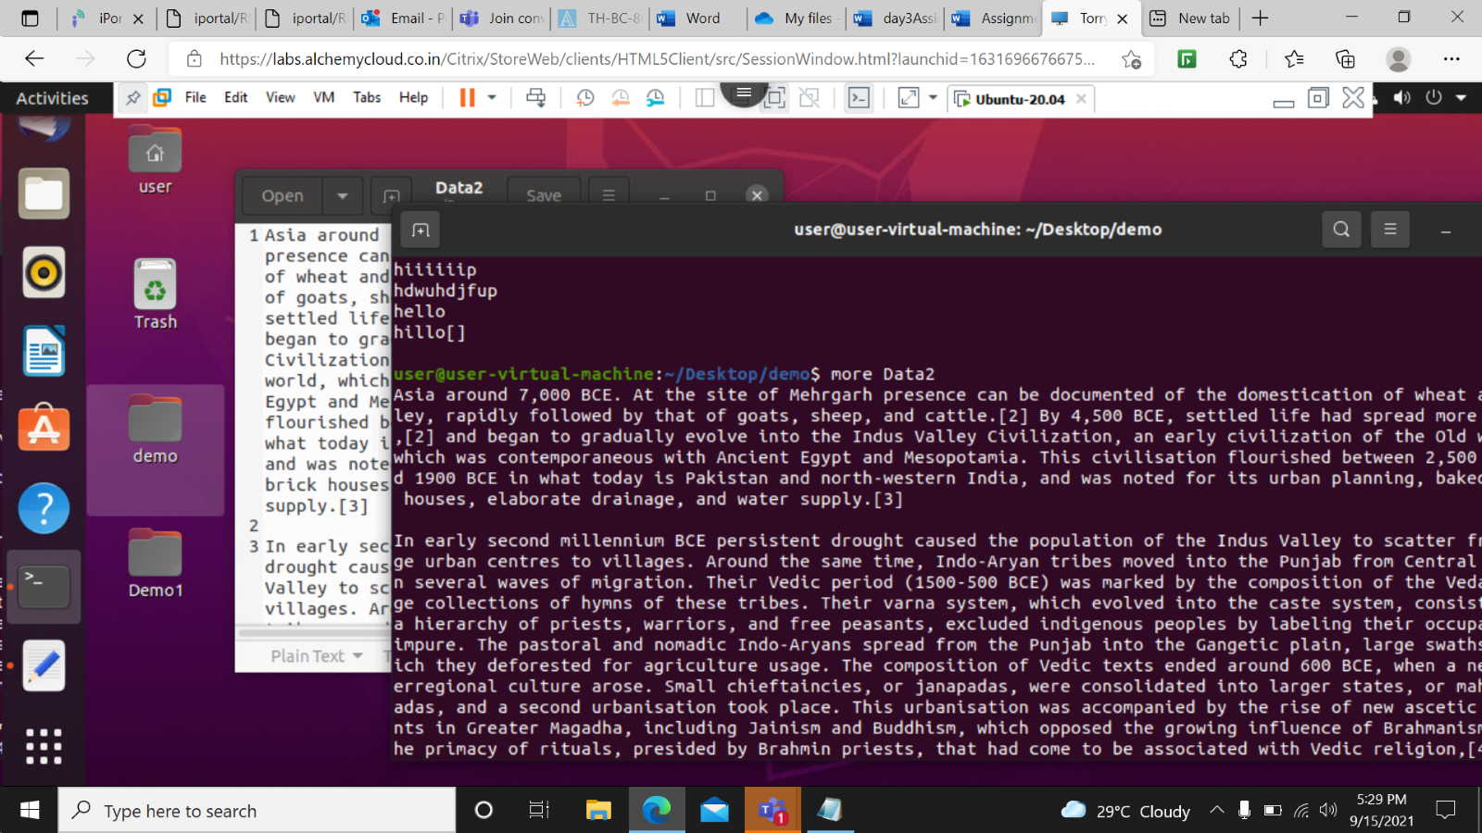

more –d Data2- Use this command in order to help the user to navigate. It displays “[Press space to continue, ‘q’ to quit.]” and displays “[Press ‘h’ for instructions.]” when wrong key is pressed.

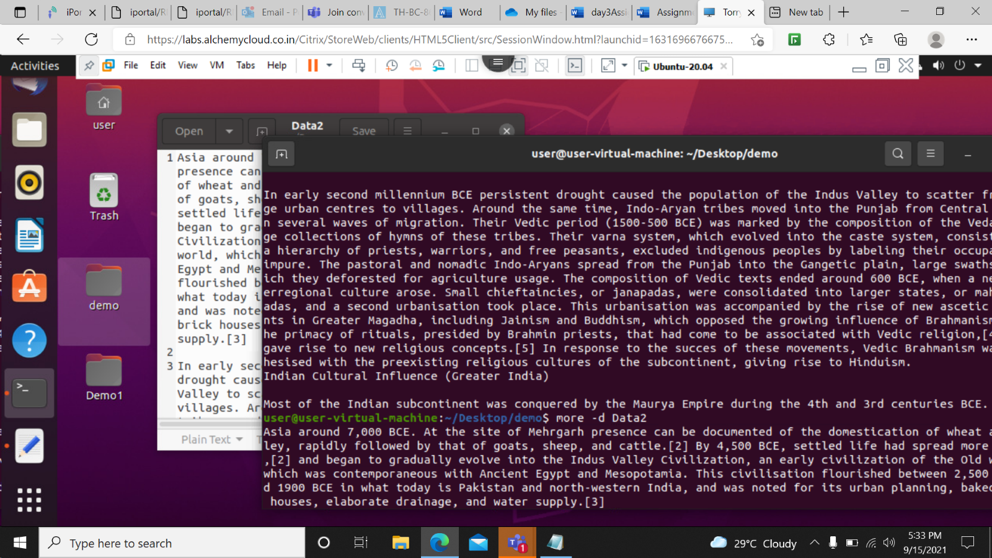

more-p Data2-This option clears the screen and then displays the textor content of file.

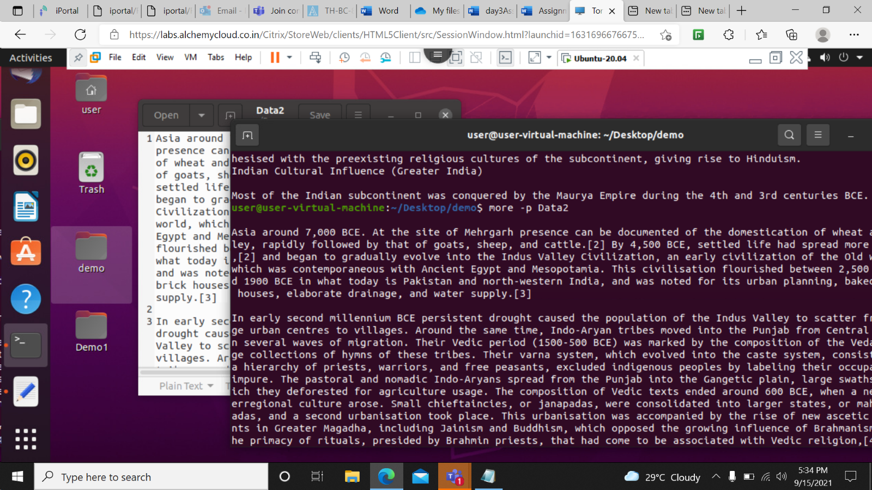

more –c Data2- This command is used to display the pages on the same area by overlapping the previously displayed text

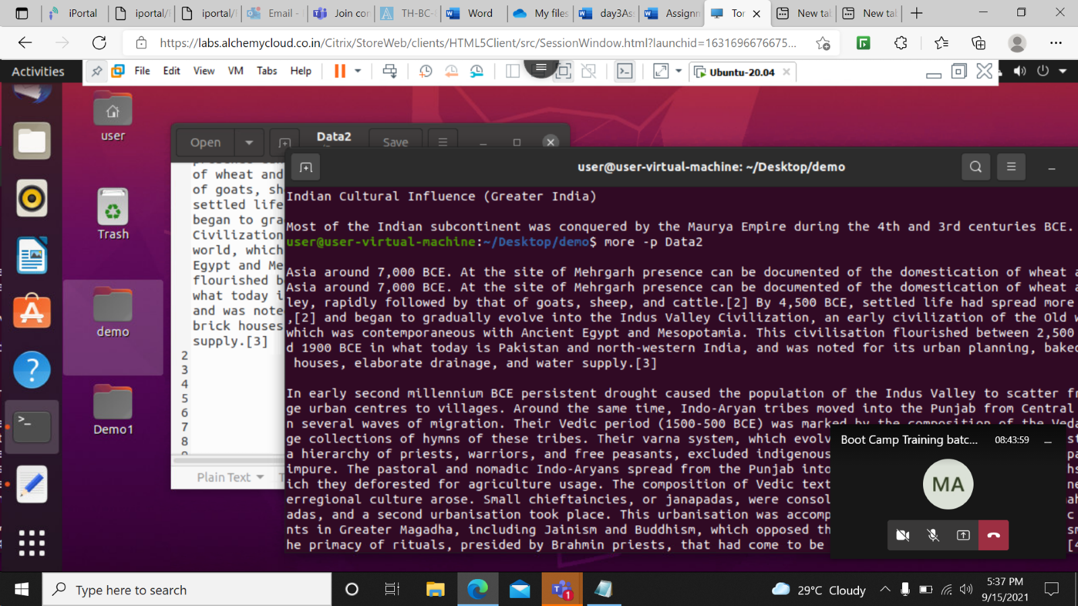

more –s Data2 – this command is used to remove the spaces in the lines.